ID | Descriptions | Expected results | Results
1.0.0 | User opens the application | Home page screen appears | 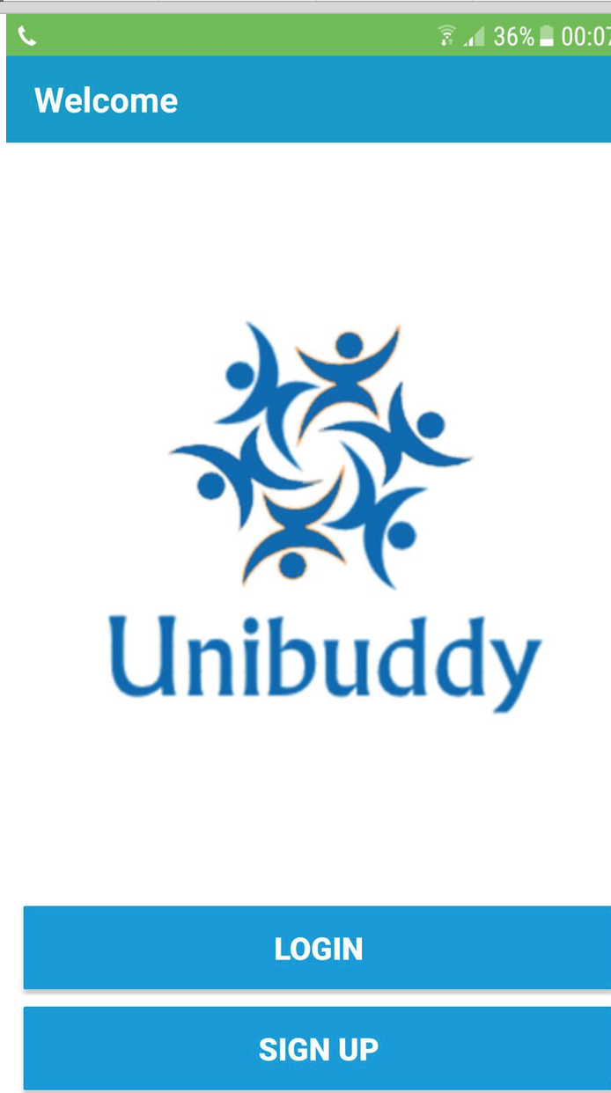  As expected
1.0.1 | If the user is on the homepage, they can either go to registration page or the login page by pressing the button to either one of them | If the user presses the ‘registration’ button, the homepage form will automatically close and the registration form will open.  If the user presses the ‘login’ page the homepage will automatically close and the login page will open. | As expected  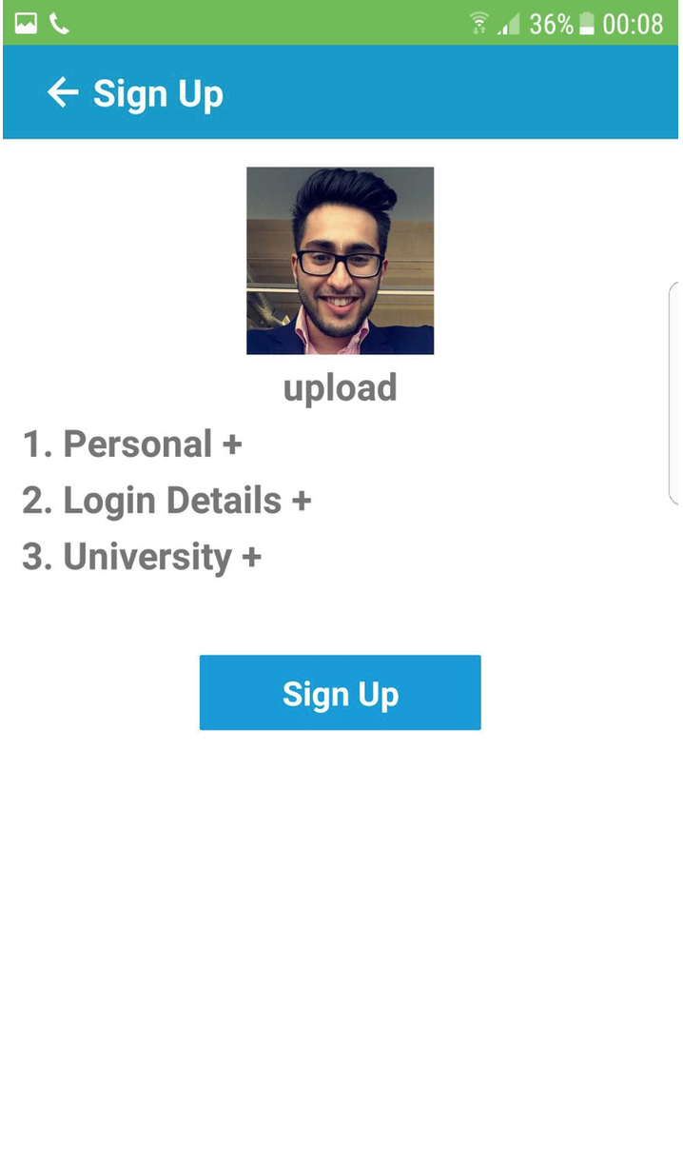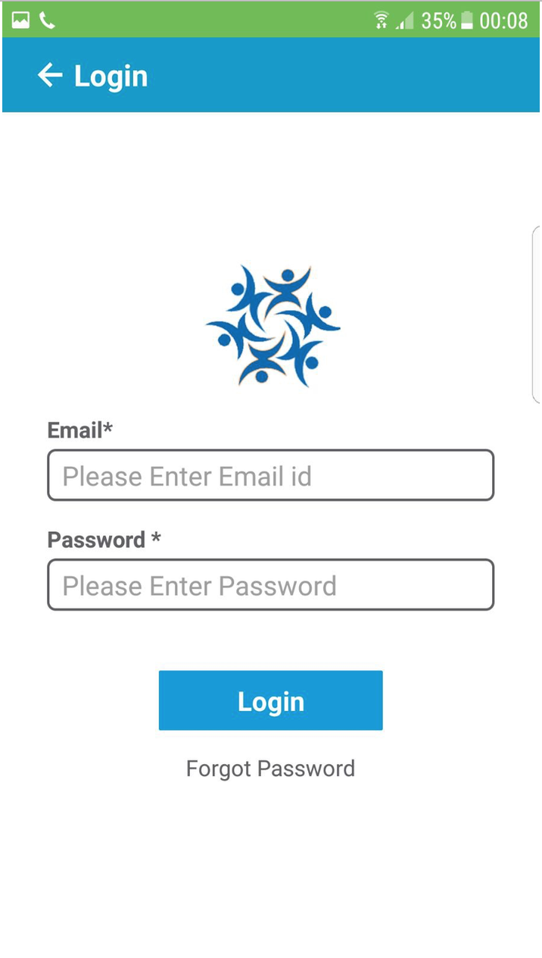
1.1.0 | If the user is on the login page they can enter their login details and press the ‘login’ button. | If the user presses the ‘login’ button and if the login is successful the users will enter the app and the ‘interests’ page will open.  However, if the user does not login with the correct details, they will get a message box stating that “please check you login details. “ and the login page remains opened for the users to try and. login again. | As expected  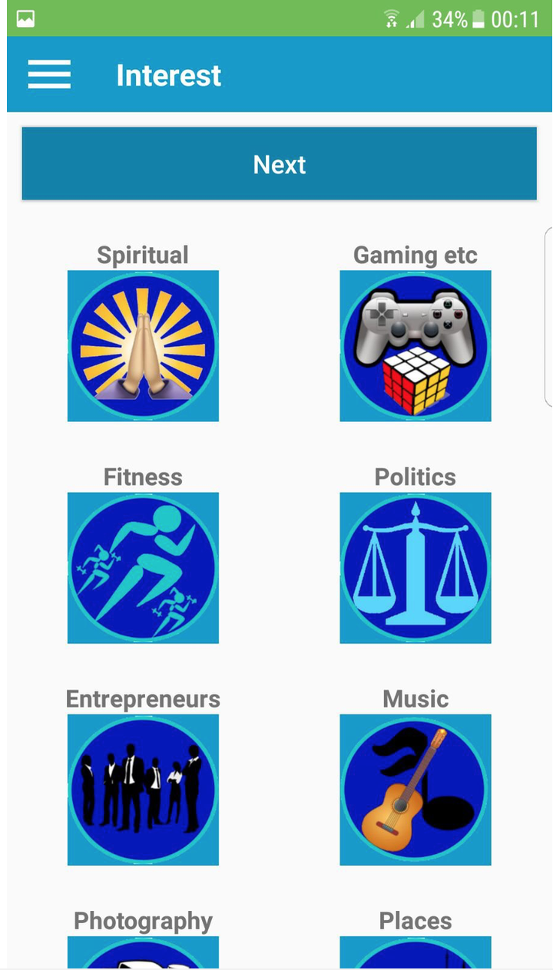
1.1.1 | If the user has logged in, and now wish to log out, they can go into the menu and click logout | The user will be logged out of their account and the main page will open again | As expected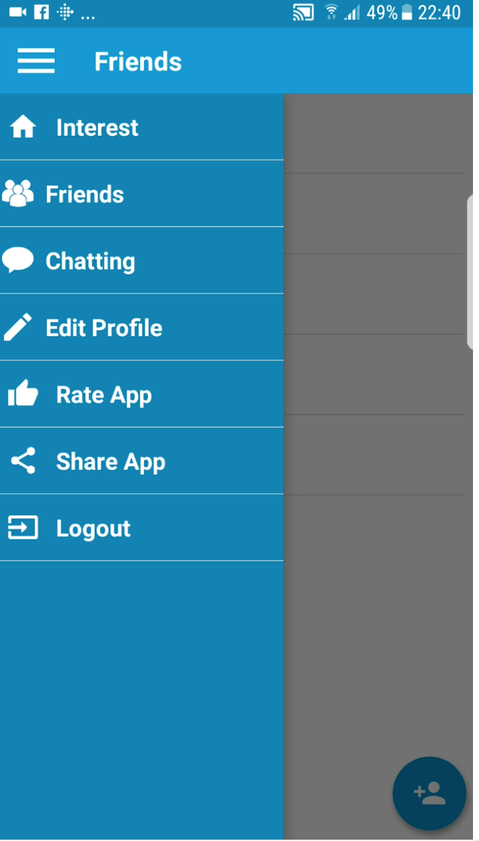
1.2.0 | The user must enter the information that has an asterisk next to it | If the user does not enter nay information next to the fields that have an asterisk next to it then the app has been built in a way that the user will not be allowed to move on to the next field on the page. | As expected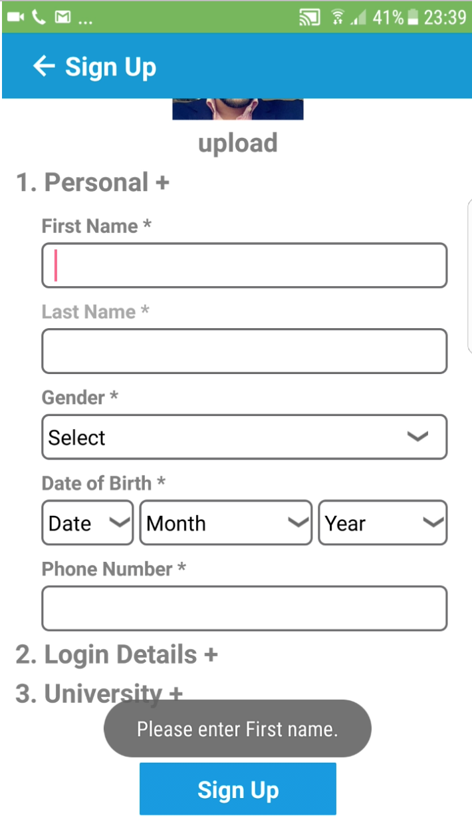
1.2.1 | The user must enter all the information that is necessary on the sign-up page | If the user does enter everything correctly and clicks on ‘sign-up’ button, then the information entered into the textboxes will save into the back-in database and the ‘interests page’ will open. | As expected  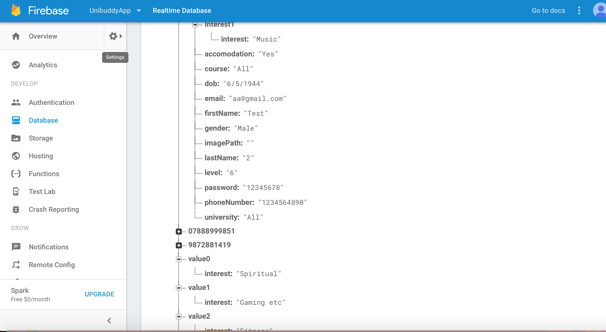
1.3.0 | Once the user is on the interest’s page the users must click on 10 interests. | If the user clicks on less or more than 10 interests the ‘next’ button on the interest pages will remain gray, whereas if the users click on 10 interests then the ‘next button’ will become blue. | As expected  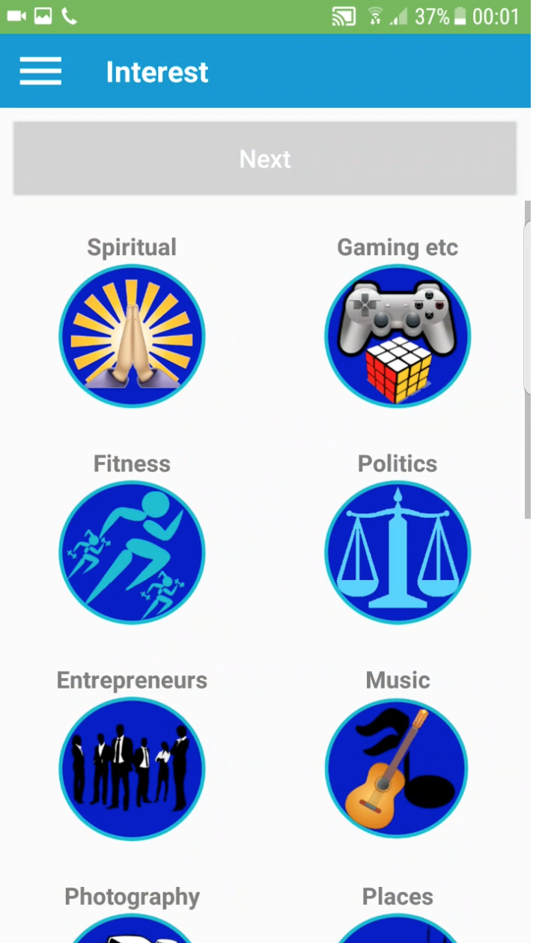
1.3.1 | The user is on the interest’s page and has chosen their interest. | If the users successfully click on the ‘next’ button on the interests page the interests they have chosen will be saved in the database. | As expected
1.4.0 | The menu is accessible by clicking on the three lines icon on top left corner of the all the pages. | When the user clicks on the menu button, the menu should open from all the pages? | As expected
1.4.1 | Menu: when the user clicks on the ‘friends’ page it should open | When the user clicks on the ‘friends’ page should open and the people they have been talking t, their names will appear on the page. | As expected  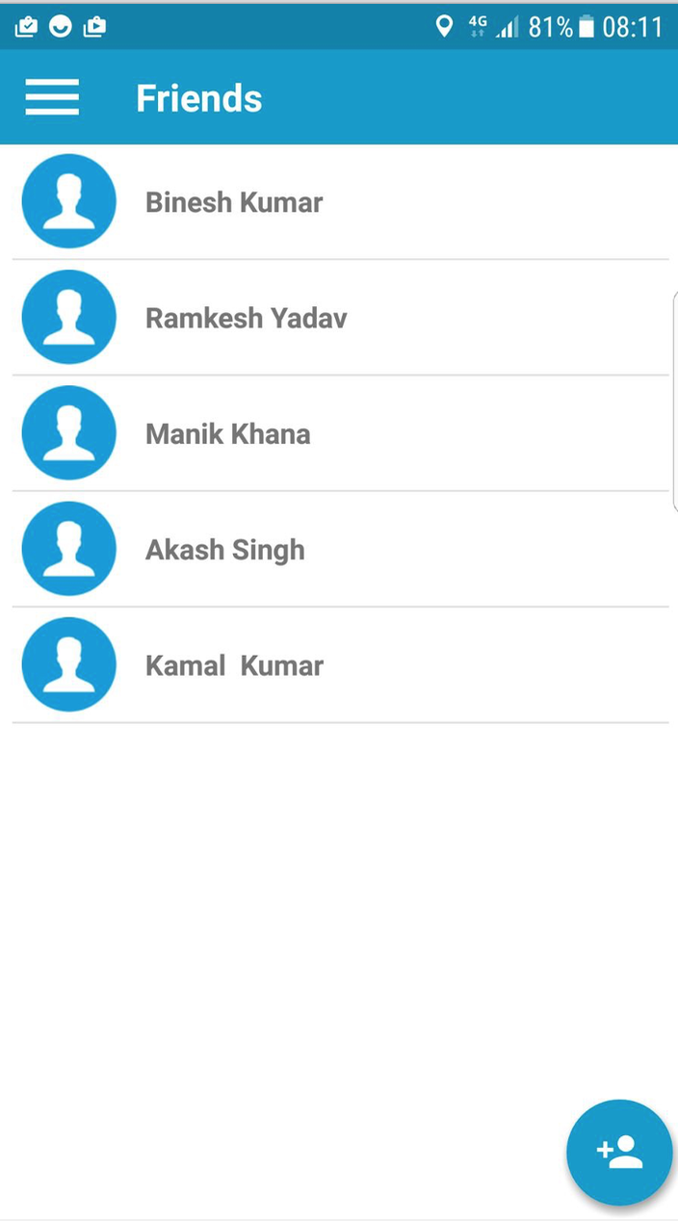
1.4.2 | Menu: when the user clicks on the ‘chatting’ page it should open | When the user clicks on the ‘chatting’ page should open and the user should be able to have a conversation with the person they wish to talk to | As expected  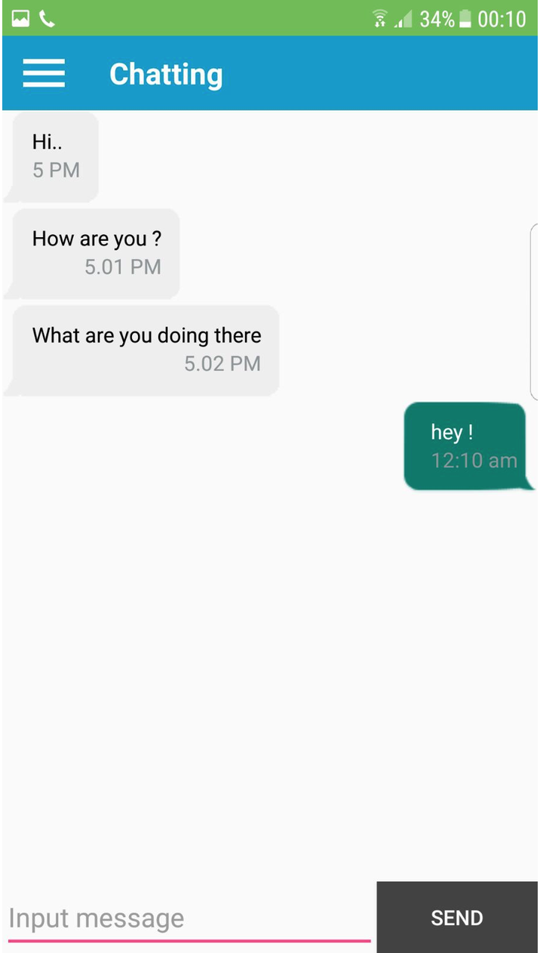
1.4.3 | Menu: when the user clicks on the ‘edit profile’ page it should open | When the user is on the ‘edit profile’ page, they can change their first/last name, password and have to retype their password. Once the user enters a change of details and clicks ‘submit’ the users information on the database changes too. | As expected  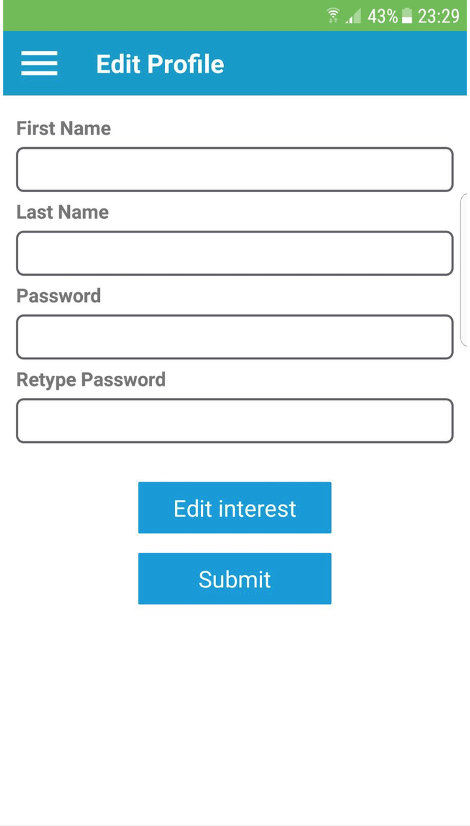
1.4.4 | Menu: when the user clicks on the ‘rate app’ page it should open | When the user clicks on the ‘rate app’ page should open and take the user to the play store | As expected  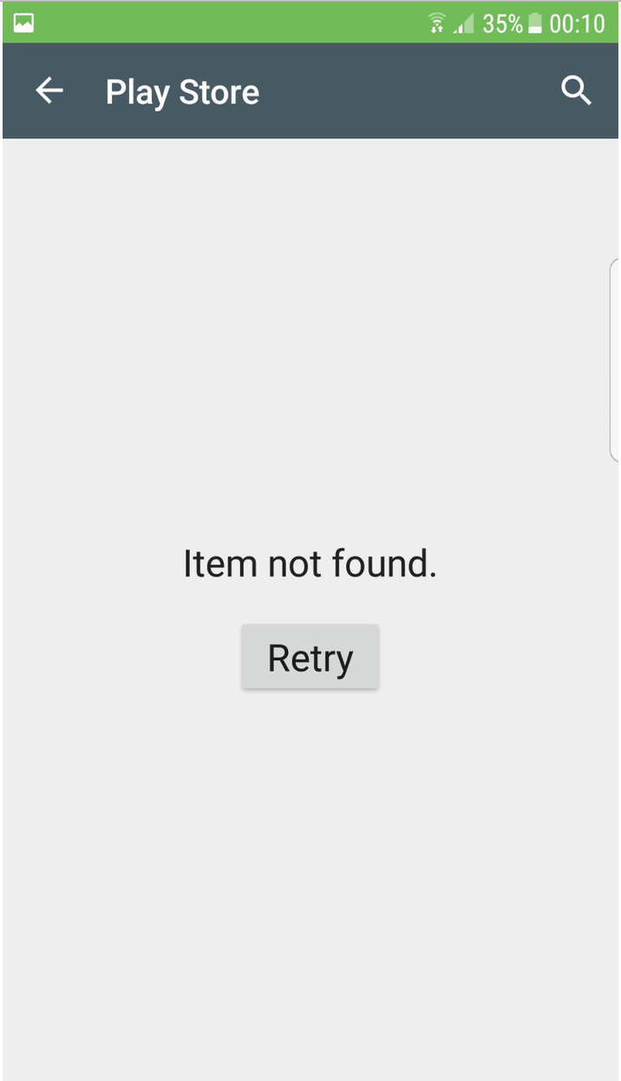
1.4.5 | Menu: when the user clicks on the ‘share app’ button, a page that half covers the current page rolls up on the screen. | When the user has clicked on the share app button and then chosen the contact that they want to share the app with it should send then a link to download the app via message. | Not as expected  This testing has failed, as when the user chooses someone from their contact to share the app with, the new application that the user chooses to send the invitation through opens however, when the users proceeds to send the link it will not work.  